**Executive Analysis Summary - Pizza Sales Data**

**1. Top-Selling Pizzas:**

- The Barbecue Chicken Pizza leads sales with 1,948 units sold, indicating strong customer

Preference for chicken-flavoured pizzas.

- Other popular pizzas include The Four Cheese Pizza and The Thai Chicken Pizza, showing a

Diverse taste preference among customers.

- The top 10 pizzas account for a significant portion of total sales, highlighting key products driving revenue.

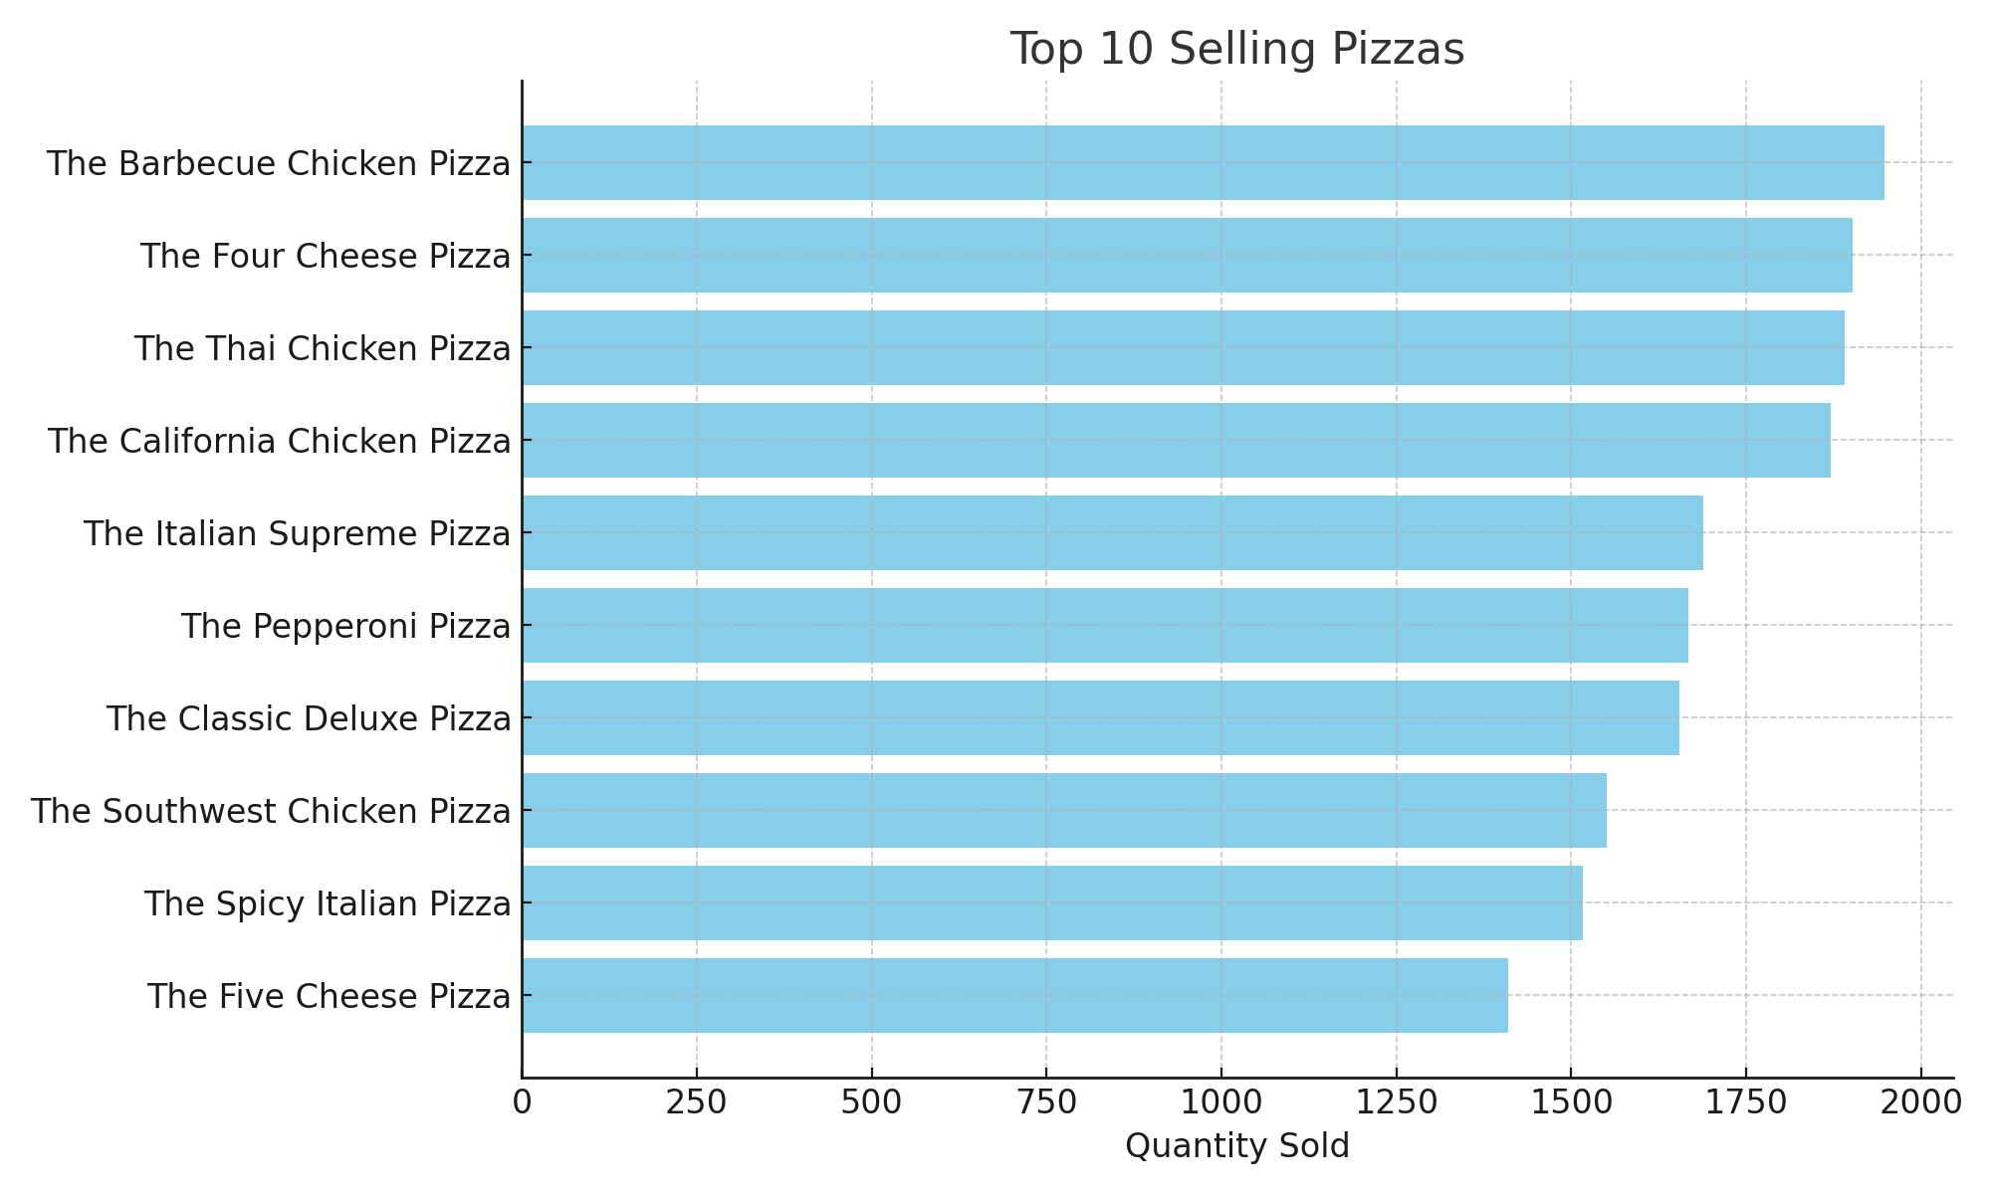

2. Sales by Pizza Category:

- The Veggie category is the highest-selling category with 8,986 units sold, reflecting a strong

demand for vegetarian options.

- Chicken and Supreme categories follow closely, indicating a balanced customer interest across

different pizza types.

- Classic pizzas also maintain a solid share of sales, showing consistent demand for traditional

flavours.

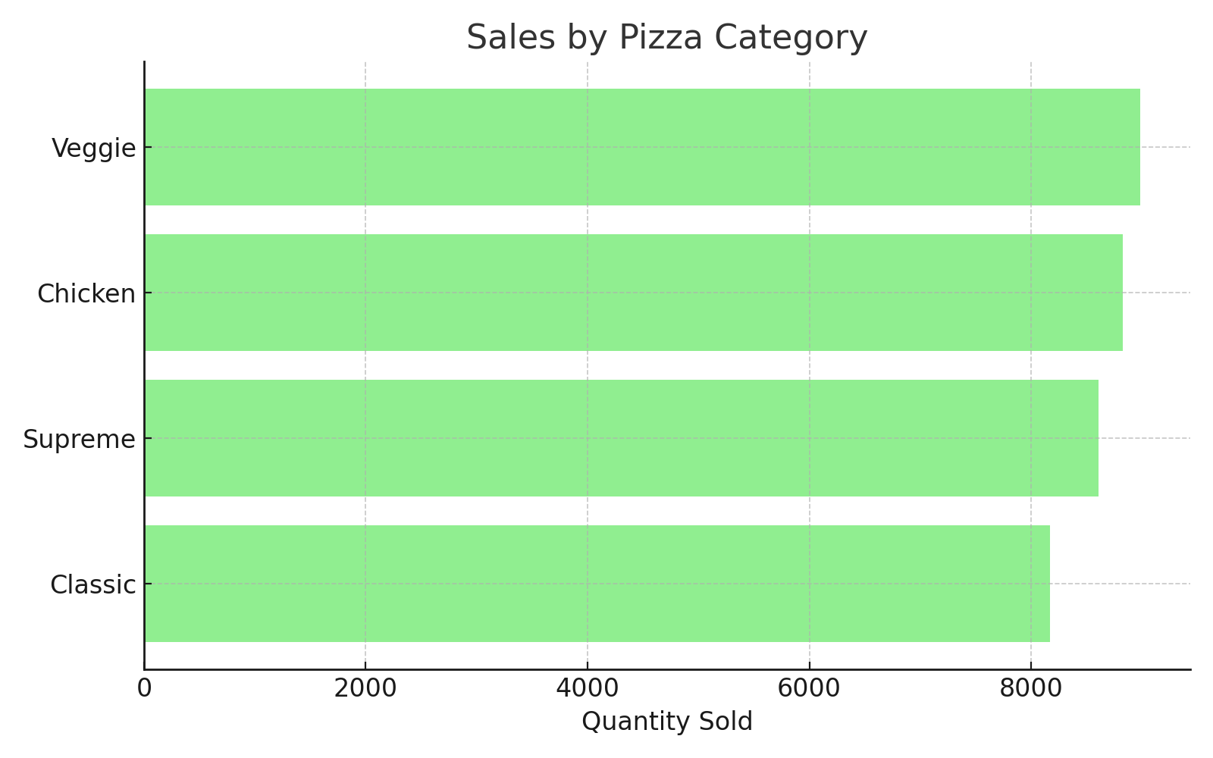

3. Ingredient Popularity:

- Garlic is the most frequently used ingredient, appearing over 20,000 times across all pizza orders,

underscoring its importance in flavour profiles.

- Tomatoes, Red Onions, and Red Peppers are also highly popular, suggesting that fresh vegetable

toppings are key to customer satisfaction.

- Mozzarella Cheese remains a staple ingredient, essential to the pizza experience.

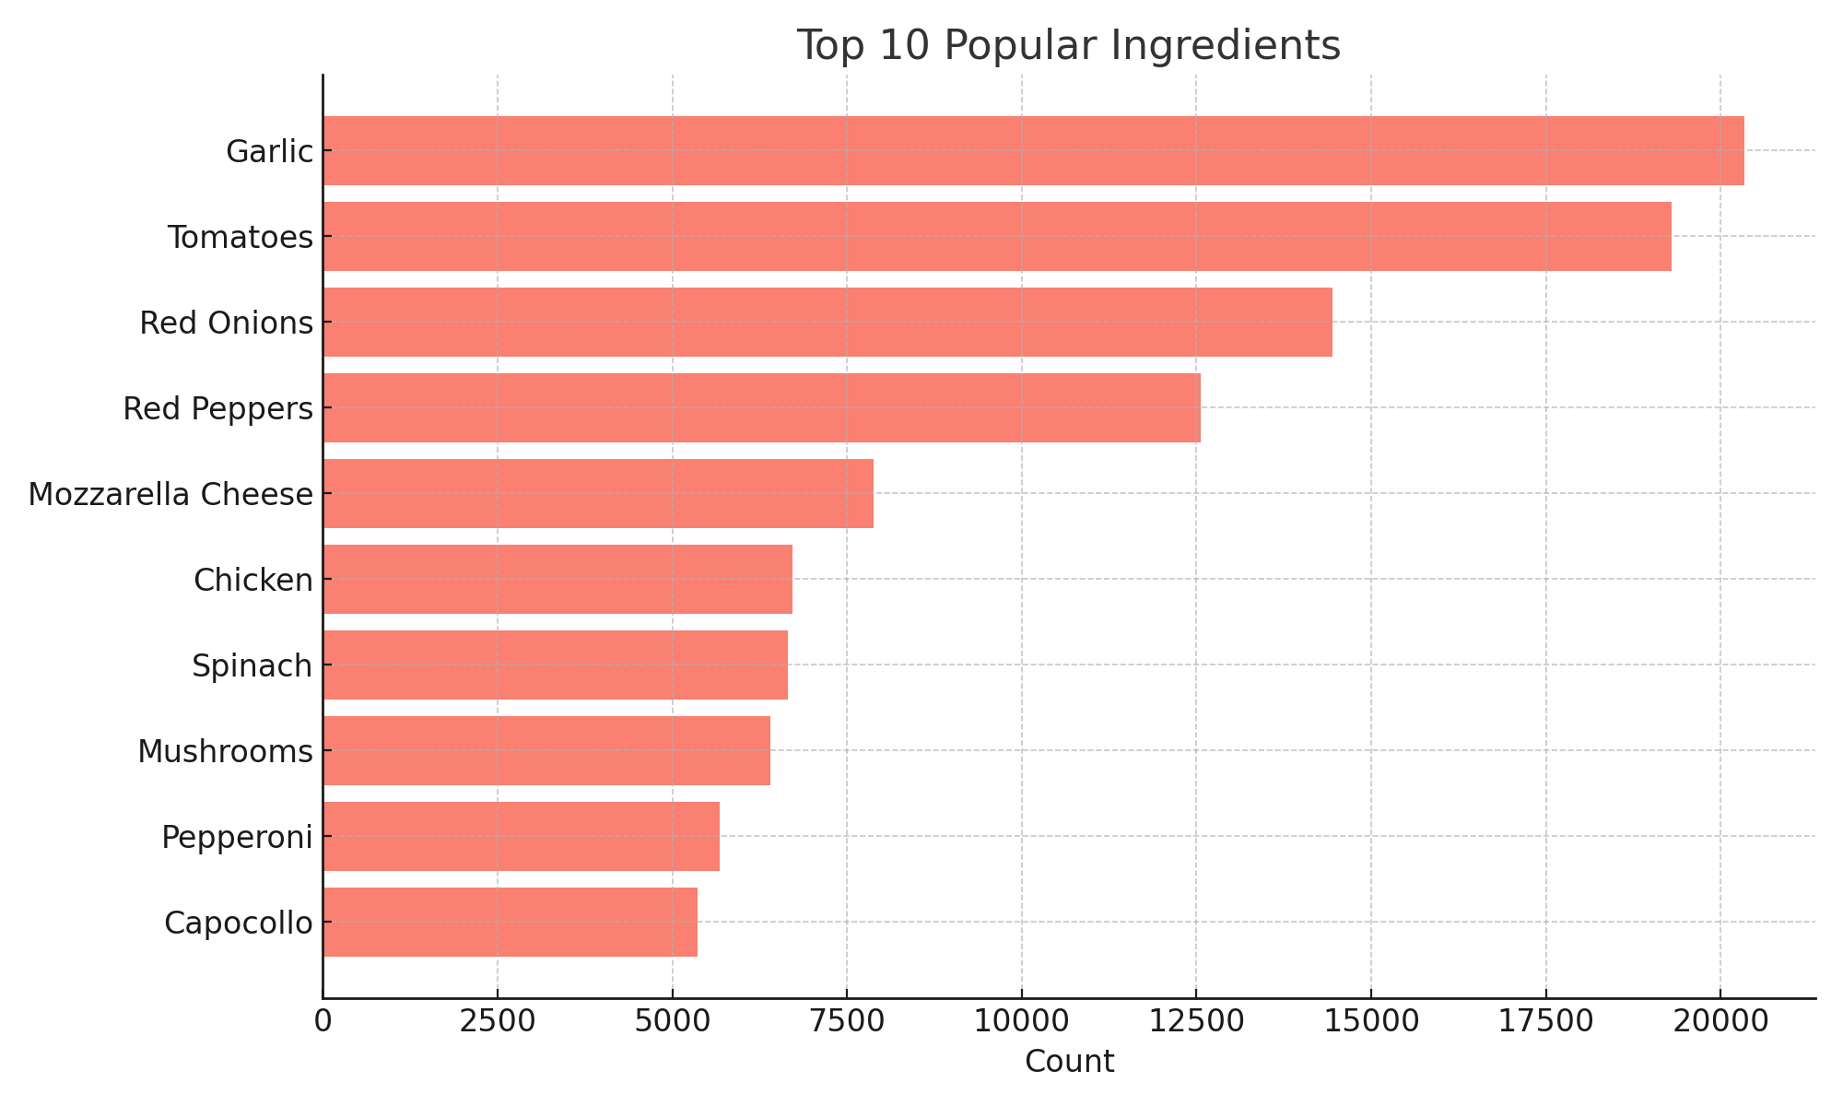

4. Insights and Recommendations:

- Focus marketing and promotional efforts on the top-selling pizzas and categories to maximize

sales impact.

- Consider expanding the Veggie and Chicken pizza offerings, as these categories show strong

customer interest.

- Highlight popular ingredients like garlic and fresh vegetables in advertising to appeal to customer

preferences.

- Monitor sales trends regularly to identify emerging popular pizzas or ingredients and adjust the

menu accordingly